General workflow for cmeAnalysis tracker

You should try a few tracking parameters and see what gives you the most accurate results. I recommend analyzing entire cells, or at least 200-500 pixel movies. Some of these slides are from Marcel Mettlen from the Schmid lab. For more details look at “cmeAnalysis_workflow.ppt” on this computer.

1. Organize your folders so that each movie is inside a folder called “cell1_2s” , “cell2_2s” etc. note there are no spaces in the folder name. The overall structure should be “yourfiles/ cell1_2s/ GFP/ moviechannel1.tif” and “yourfiles/ cell1_2s/ RFP/ moviechannel2.tif”
   1. You should be able to do this automatically by running “makeCMEanalysisFolders_Bulk_twocolor.m”
   2. If that doesn’t work: try putting all your GFP movies from a single condition in one folder, and run “makeCMEanalysisFoldersBulk.m” for that folder. Repeat for each color and each condition.
   3. If that doesn’t work either, you can sort each movie to its own folder for individual analysis by putting all your movies in one folder and then using “makeCMEanalysisFolders.m”
2. Open Matlab.
3. Open ‘runCMEanalysis.m’ (it’s in Documents/ MATLAB)
4. Set the gap size and search radius limits
   1. You can try the parameters you were using in Imaris. Ideally you should try a few gap sizes and tracking radii. Currently we’re using gap size 3 frames, tracking radius between 0 and 2.3 pixels (250 nm) for our movies
5. Click “run”
6. 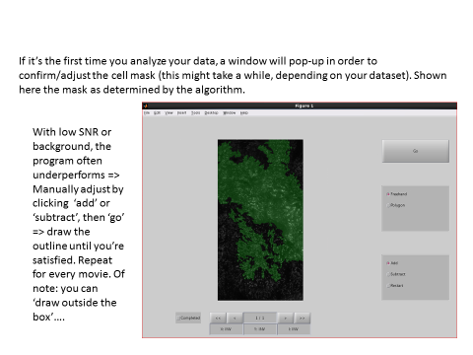
7. 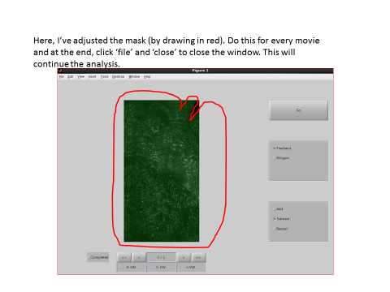
8. When the window “Choose condition folder” pops up, select the top folder (the folder above “cell1_2s”, i.e. “yourfiles” in the example above)
9. Want to visually check the accuracy of your tracking? Go to step 14 first
10. To visually check how accurate your tracking was, for the parameters you used:

* In Matlab 2013a run ‘runCMEviewer.m’
* Within the cmeViewer, try toggling viewing Detections, Tracks; display by Lifetime (we don’t currently agree with the creators on the biological significance of ‘categories’); Select Track; Generate Montage; Print Figures.
* I modified Generate Montage so that you can decide how many montages to make at once so you get a sense of how accurate the tracker was. (check ‘show detection’ before you Generate Montage). You can then save those montages with Print Figures.

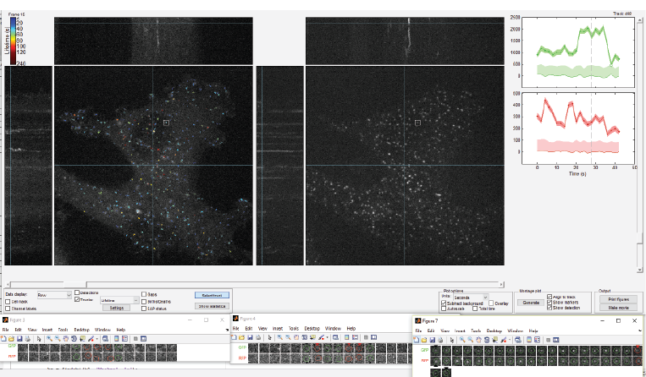

* Note that the post-processing steps (after tracking and before plotting) differ a bit between Sun’s program and this one; but this gives you a general sense of how the tracker is doing.